*Information Management System*

RS Dry Cleaners Software-

Requirement Analysis

And

Table Designing



Submitted to : Mr. Parteek Bhatia

Group Members :

1. Gangesh Dhar 101503076
2. Ishita Sharma 101503100
3. Ishaan Kohli 101503097

*Table of Contents*

1. Introduction……………………………………………………i
2. Requirements…………………………………………………..ii
3. Project Description…………………………………………….iii
4. Workflow……………………………………………………….x
5. Table structure and constraints…………………………………xi
6. Acknowledgement……..……………………………………..xiv

*Introduction*

The main purpose of this Database software is to automate the Laundry shop, R.S Drycleaners in COS in Thapar University, Patiala. The shop had opened a long time back and till date works on a manual system. The shop maintained no records in form of registers and relied on their memory to know which service was to be done on which clothes. Since they never record anything, there are possibilities of errors. This system is only good for use if less students used it, but with increasing student population in the campus, the need of automation arises since the manual system has drawbacks of its own when services are to be performed in large number. Hence, to serve this purpose, and also taking the opportunity given by our college we are making a DBMS software to automate the shop, thus reducing some amount of workload from the shop workers.

The process that the shop follows is described as follows:

1. The first step is submission of clothes, and then enquiring which service is to be done on which cloth. This is not noted down anywhere and purely remembered by the owner.
2. Then they write the Initials of the name of the student and his/her Hostel name.
3. After this, before closing the shop, they open all the laundry bags one by one and then write the same initials written on the laundry bags on the clothes for ease of identification.
4. Then they take these clothes to their houses for performing the required service.
5. Then they perform the services and after the service is done, bring back the clothes to the shop where they are sorted again.

It is easy to imagine, that when the amount of clothes are more, then there are chances of error for example loss of cloth, sending wrong clothes etc since the identification technique they are using is not upto the mark and plus the added problem of not maintaining a record. These factors are significant, and can result in loss of clientage which is not desired by and shop. Hence, until it’s too late to recover, the necessary steps should be taken.

The advantage of maintaining an automated system is that, all such errors can be avoided plus it reduces the burden on the shop owner as well and hence they can concentrate more on the service rather than worrying about other things.

As we found no manual record of data and transactions we are making some assumptions which may or may not exist in real and proposing the solutions for the same.

*I*

*Requirements*

To make this software as effective and efficient as possible, we had frequent meetings with the shop owner to know the working of the shop so that we don’t change the way they work but just make that work easy. The reason we chose this shop for automation was because we as students availed the facility of this shop and have seen the growth in customers and add to that, we had also heard from some students that some clothes were getting lost or sent to wrong person and moreover the students themselves had to make a record of what they sent for laundry due to this. Hence, we chose the shop for this purpose.

In our meeting with the shop owners, we had asked that if they maintained any records and there answer was no. They only sorted the clothes by writing the initials of the name of the student who had submitted the clothes. Upon being asked if someone demanded different service for example washing and some clothes for dry clean, they said that they relied on their memory to perform the tasks. We had also asked them that whether they would want to automate their shop through a computer and were comfortable with it to which they said yes.

So, it became obvious that automation is required for the shop and hence started to work on the initial design of the databases and then also saw what tables were required and what constraints were required. Hence we came with this,that each of the facility would now be independent and all the clothes would now be marked with unique bill number generated by the software which would make the sorting easier than it used to be. Also, all the bills would be calculated by the PL/SQL coding/queries only, further reducing the load. This is required due to the fact that now in the coming years also the students will increase. Hence it is required for the better working of the Shop. In the subsequent meetings also we got to know that some clothes were being reported as lost or exchanged causing discomfort to the students and putting the reputation of the shop at stake and we didn’t want any of the students to complain about it because it was due to the increase in workload of the owners of the shop.

In technical terms, the problems are as follows:-

1. Data is not secured
2. Data integrity is not maintained
3. Data is inconsistent

*ii*

*Project Description*

As we all know that in a business keeping records of every transaction be it financial or any other sort of information which is extremely important for the business. As in the case of “laundry shop” the information students and what their demand is the basis of their business. If anything goes wrong with this information they are the ones who will suffer a loss which can further lead to decrease in their credentials, meaning loss of business.

In this project we propose to create a database in which all the information is stored comprehensively in a virtual place ie digitalized storage and not manually.

The process starts with the making the employees table for storing all the information on employees.

|  |  |  |  |  |  |  |
| --- | --- | --- | --- | --- | --- | --- |
| S No | Ename | Emp_id | DOB | Hire date | Designation | Contact No |
|  |  |  |  |  |  |  |
|  |  |  |  |  |  |  |
|  |  |  |  |  |  |  |

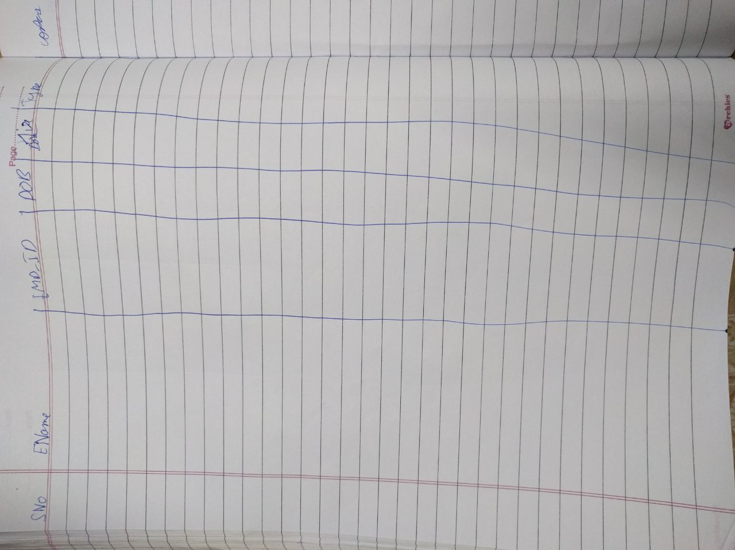

*iii*

Then storing all the information on the machinery they are using and their details.

|  |  |  |  |  |  |
| --- | --- | --- | --- | --- | --- |
| SNO | EQUIPMENT NAME | Department | Last date of service | Due date of service | EQUIPMENT COST |
|  |  |  |  |  |  |
|  |  |  |  |  |  |
|  |  |  |  |  |  |
|  |  |  |  |  |  |

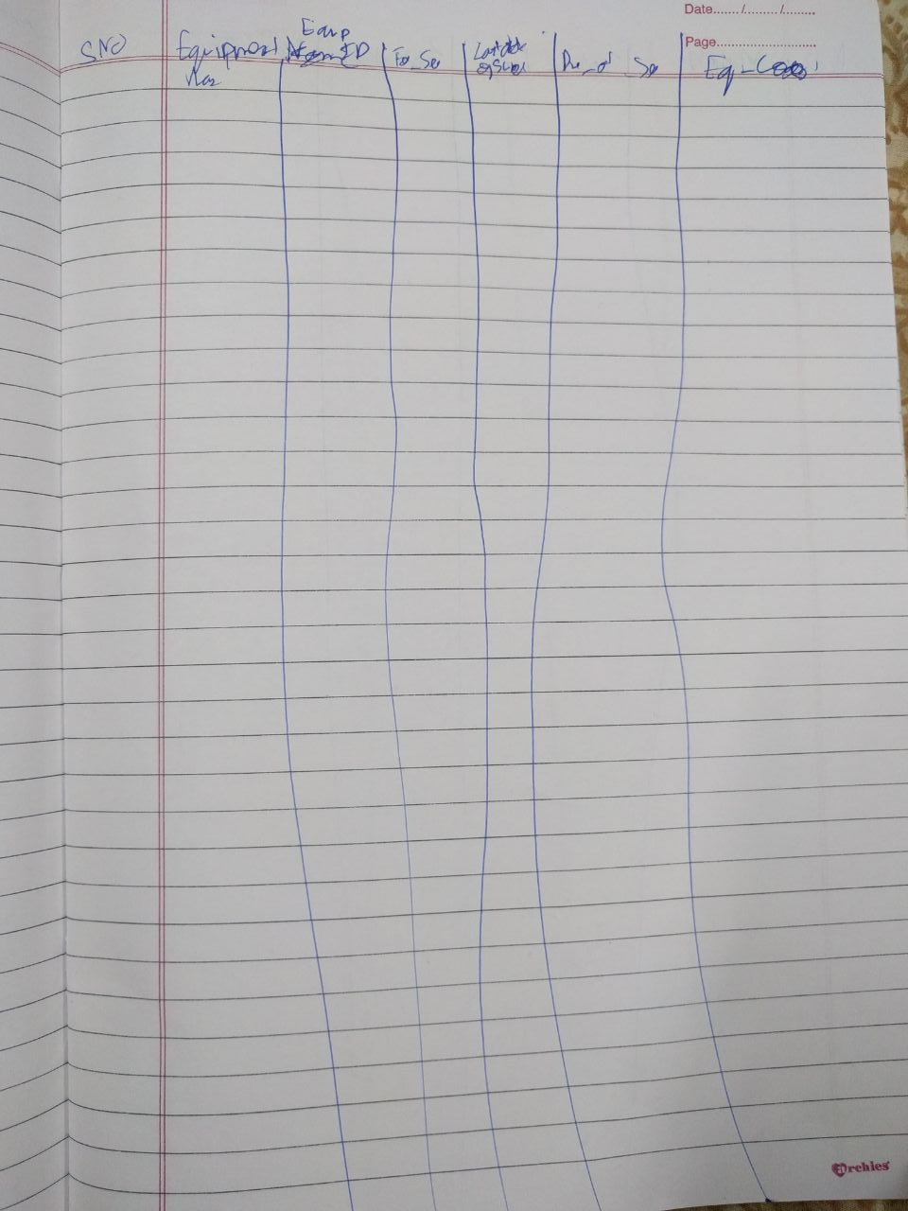

In carrying out their duties they would require certain products or materials without which the required job cannot be completed. As its mandatory requirement so a table is created for storing all the miscellaneous items required.

|  |  |  |  |  |
| --- | --- | --- | --- | --- |
| Mat_Desc | Mat_Quantity | Qty | Total_price | Supp_name |
|  |  |  |  |  |
|  |  |  |  |  |

*iv*

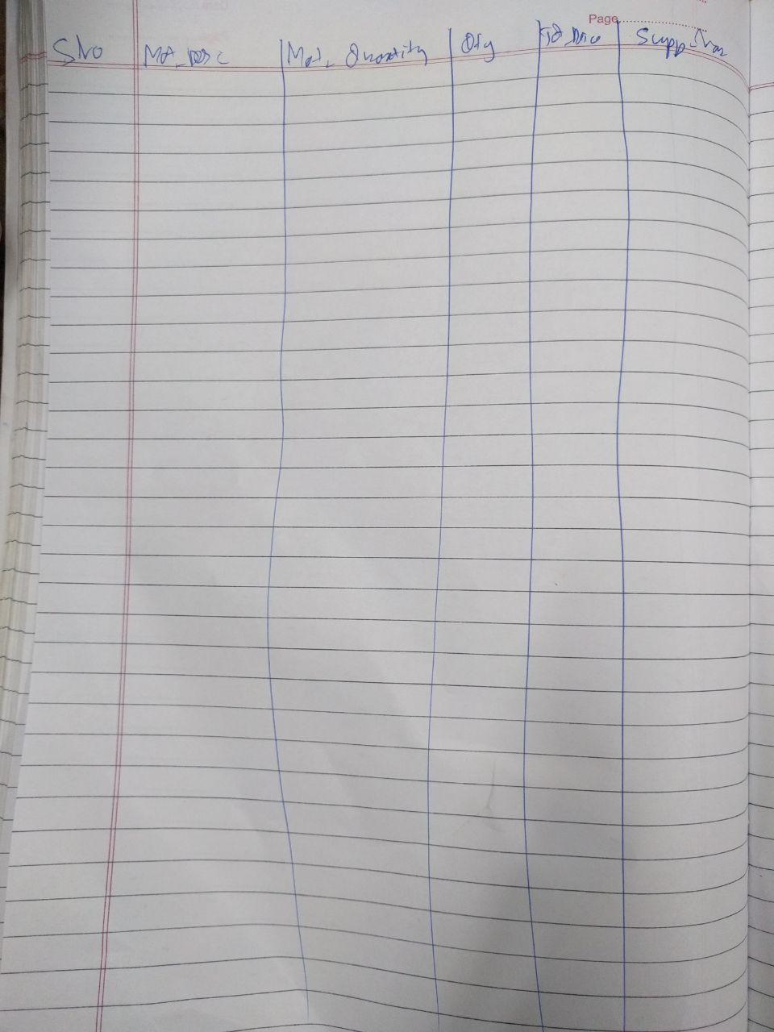

These were the tables for storing the information related to the shop. Its employees, the machinery it uses and all the miscellaneous items require to carry out its job.

*v*

Now lets move on to the services the shop is offering. All the services the shop is going to offer will be stored in a master table so that when later on it expands its services up gradation is an easy process. Rather than modifying a no. of tables to meet our new requirement we will just add or delete from this master table.

|  |  |  |
| --- | --- | --- |
| Ser_id | Ser_Desc | Price |
|  |  |  |
|  |  |  |
|  |  |  |

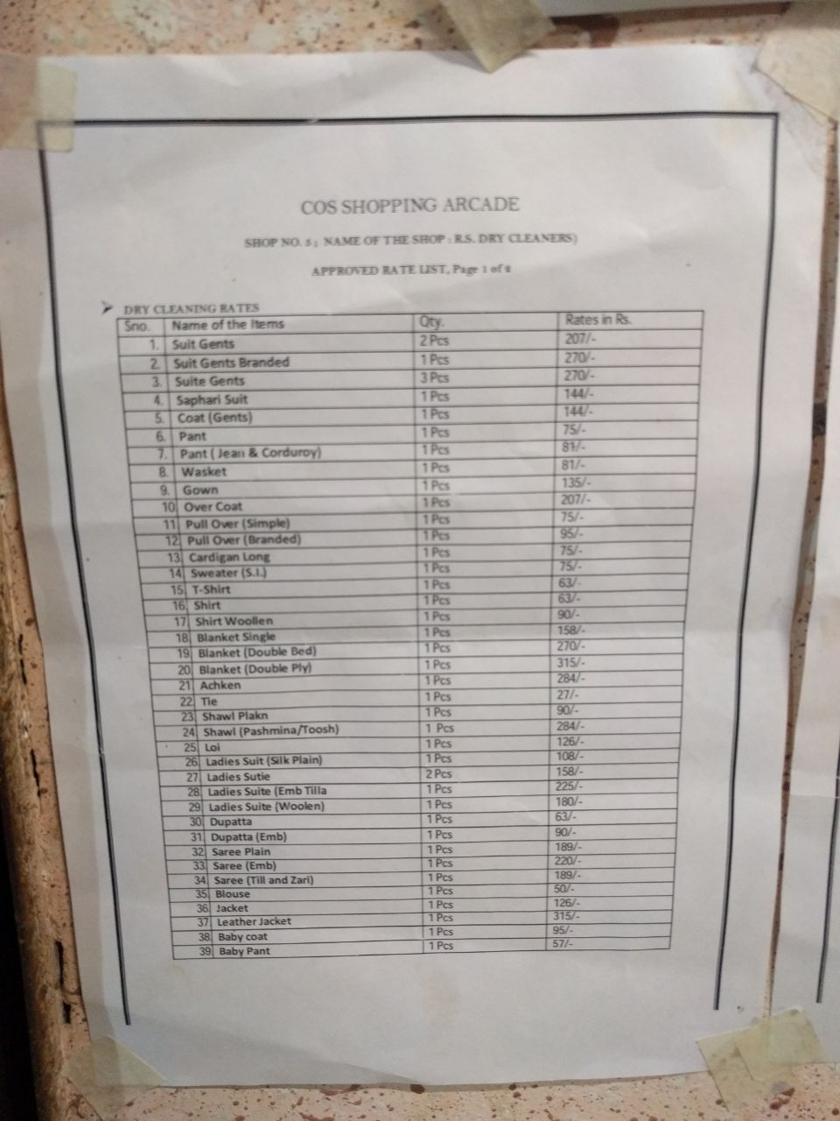 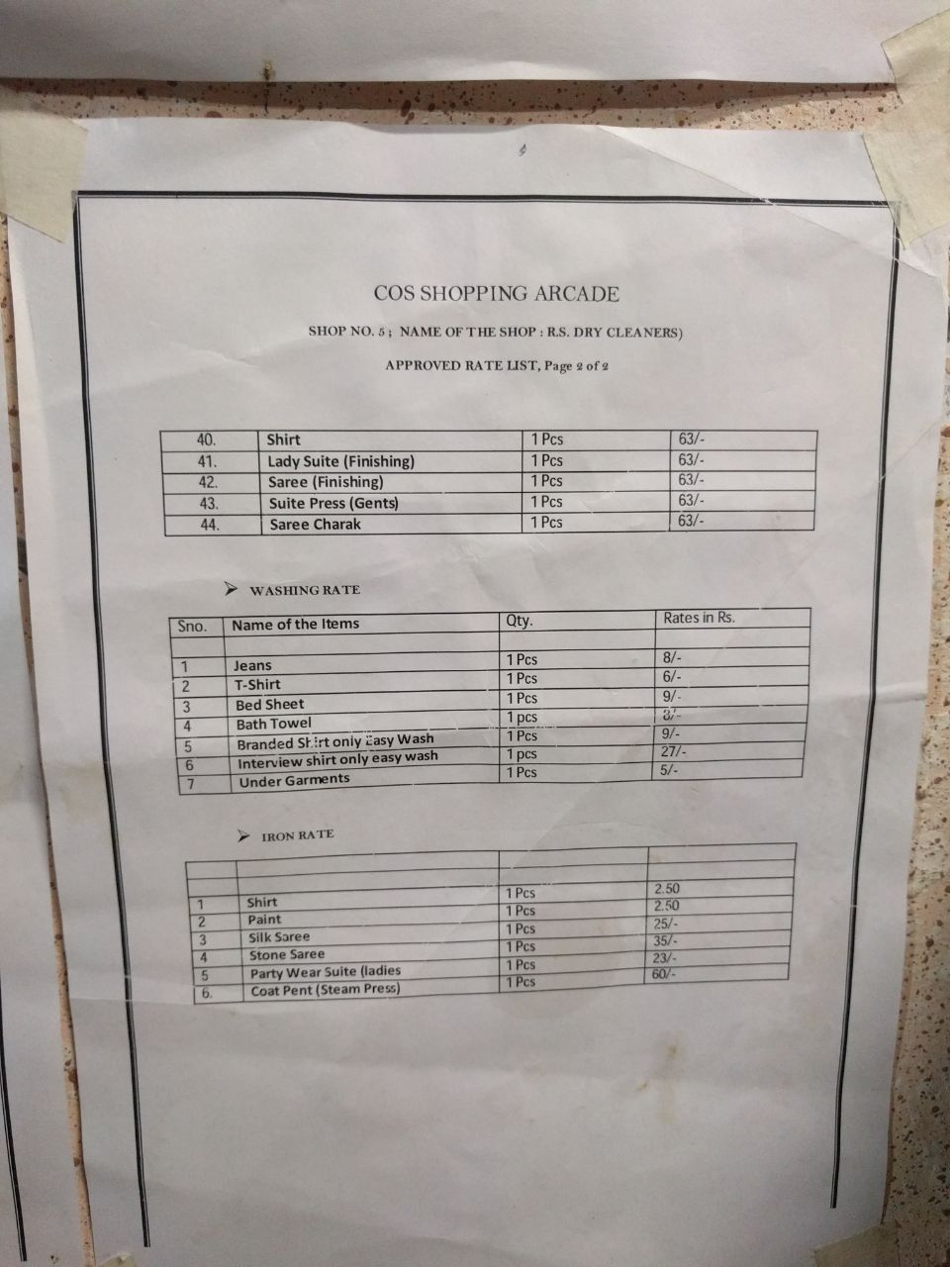

Before taking any orders for its services the shop will ask the individual to register.

For storing the details of the students of thapar university who are regular customers at the laundry shop. So that they don’t need to ask for their complete details again and again. It will also help to create a record of his previous transactions with the shop.

|  |  |  |  |  |  |  |  |  |
| --- | --- | --- | --- | --- | --- | --- | --- | --- |
| S No | Name | Sex | Roll No | Class | Year | Hostel | Room no. | Mobile Number |
| 1 | Ishaan Kohli | M | 101503097 | BE | 2nd | K | B331 | 7503069020 |
| 2 | Gangesh Dhar | M | 101503076 | BE | 2nd | L | B350 | 9888445566 |
| 3 | Ishita Sharma | F | 101503100 | BE | 2nd | I | 354 | 9876543210 |

*vi*

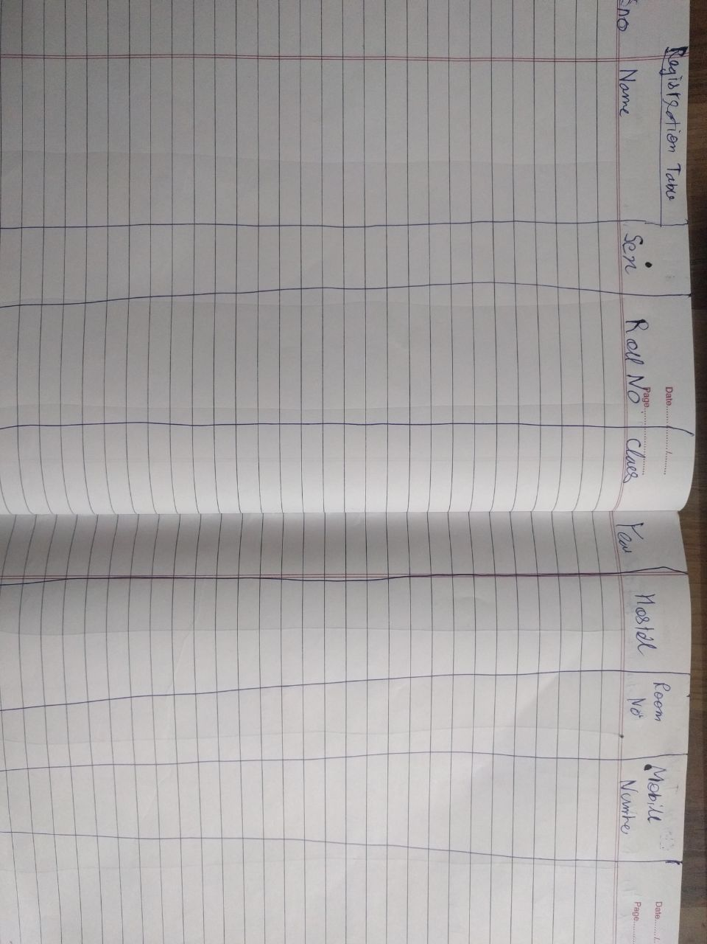

Order by the student. The details of this will be stored in different tables because a single student may request for more than one services and storing all together will be a cumbersome process which will definitely lead to problems when the size of data base increases. But we will create a table which will create unique code as bill_no for each student which will be used as a reference for the services requested by the student.

It will also serve as the purpose of recognizing history of financial transactions of the shop with a particular student.

|  |  |  |  |  |  |
| --- | --- | --- | --- | --- | --- |
| Sno | Bill_no | Roll_no | Date of Sub | Status | Total Due |
|  |  |  |  |  |  |
|  |  |  |  |  |  |
|  |  |  |  |  |  |

*vii*

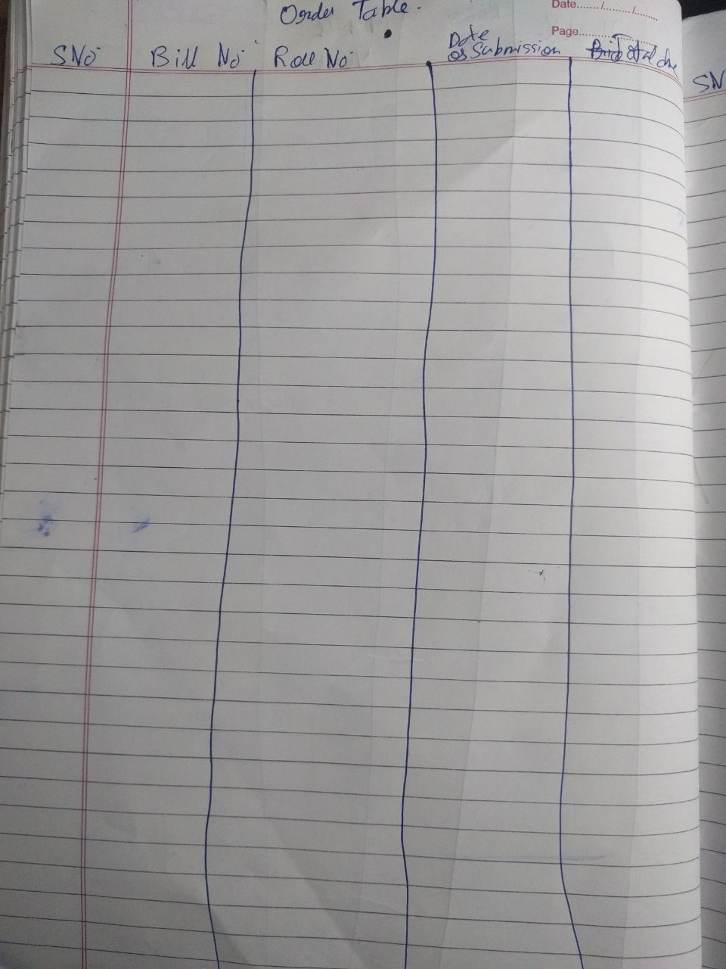

The transaction which takes place between the client and shop is stored in this table.

It will make things easier to calculate and hand over the bill to the client also storing it in records.

|  |  |  |  |  |
| --- | --- | --- | --- | --- |
| Sno | Month | Tot_Exp | Tot_Earn | Net_earn |
|  |  |  |  |  |
|  |  |  |  |  |

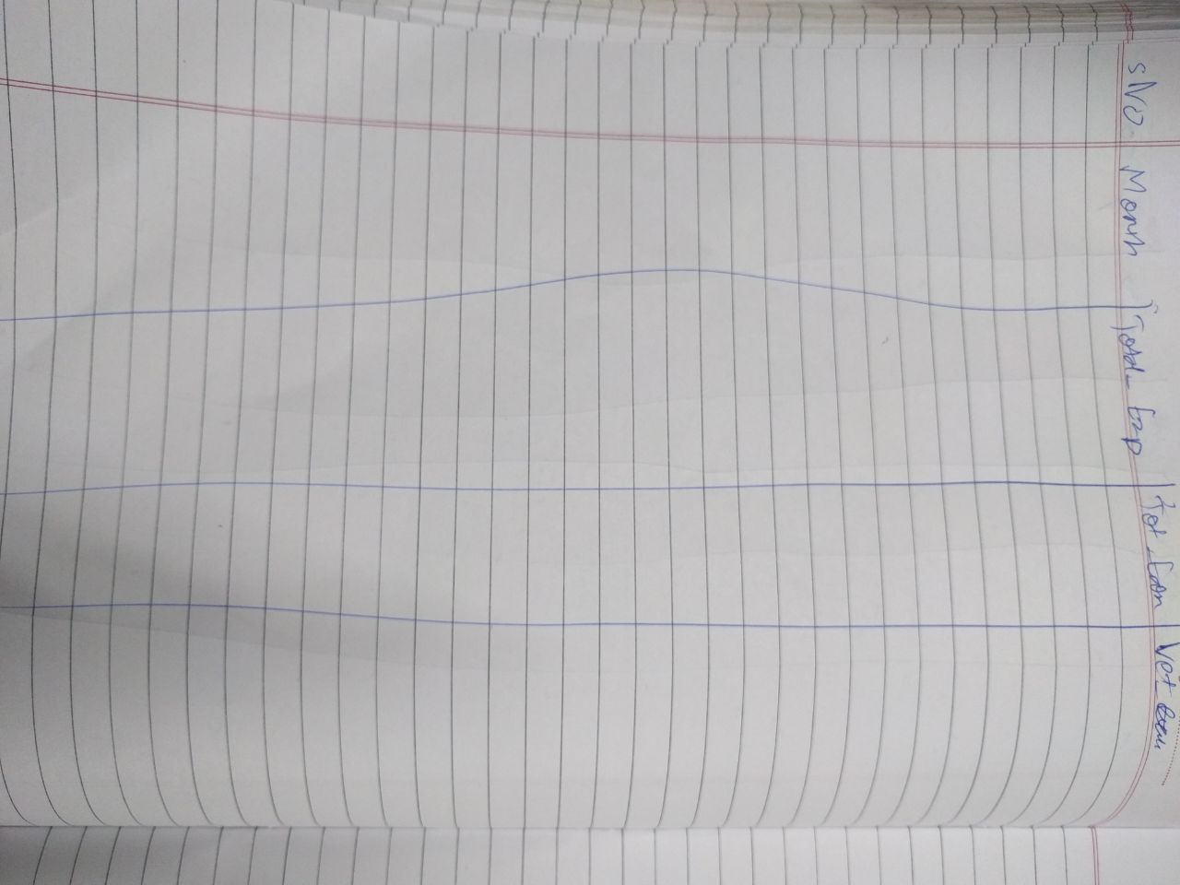

*viii*

This table will help to measure the Net earnings of the shop on the monthly basis and will help measure the growth of the shop.

|  |  |  |  |
| --- | --- | --- | --- |
| Bill_no | Job_id | Qty | Due |
|  |  |  |  |
|  |  |  |  |

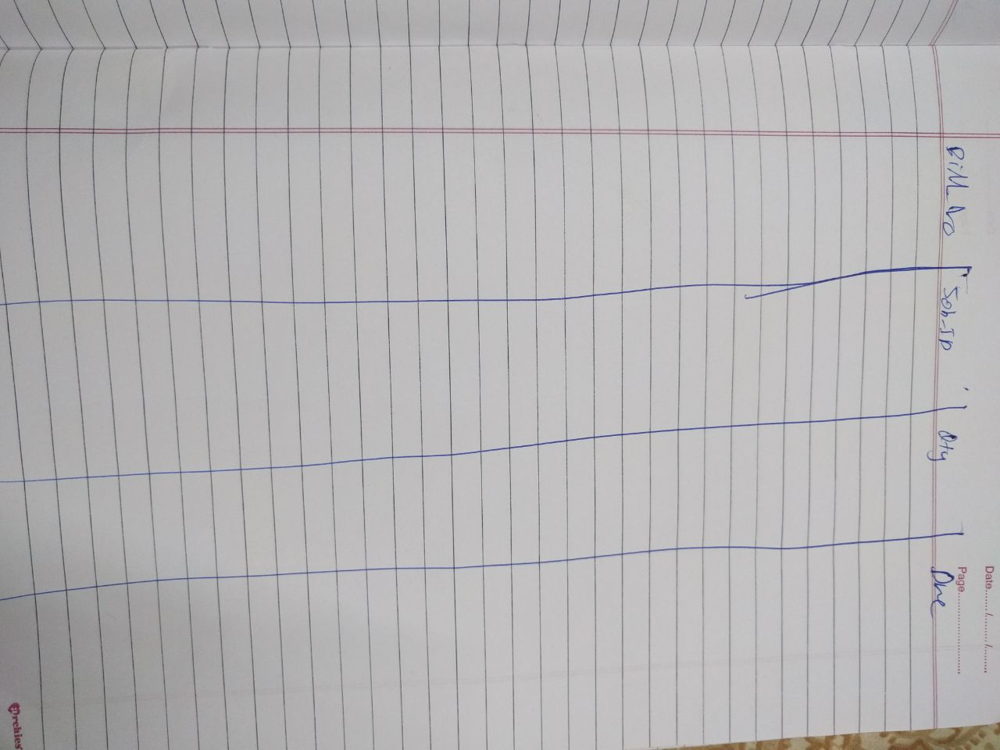

This is the table for each of the services offered by the shop, every service has its own unique table. We would calculate each services due from this table and add them and send to the order table.

*ix*

*Work-Flow*

**All the internal queries would be written in SQL only and not in the Front end.**

As described in the table above, this section would summarize all of it. As seen, now the student will have to register himself at the shop before availing any service to keep record of every facility he avails and if there is a need to contact the student in cases when the order is ready.

After registration, he will asked what clothes he has to submit and what facility he has to avail (washing/ironing/dry cleaning/tailoring). A unique bill number would be generated corresponding to his clothes, and then it will be expected, that the shop owner attaches a paper/cloth with the bill_no so that it is easy to sort the clothes after they have been washed.

Now, this bill number will be referred to the service tables, where the record will be maintained, that which clothing has gone to which service. No entry would be allowed without a valid bill number, and duplicates won’t be allowed. To each bill number, there would be a corresponding job_id, whose basic need is to calculate the due for that service since every services cost different. Thus, bill number can be repeated in that table provided that the corresponding job id is different, since there can be a case where a student submits 2 Tshirts and 1 bedsheet for washing, but price of washing would be different for both. Each service would have a different table so that complexity is reduced. Also in this table, the due amount for each job will be calculated and all the dues would corresponding to a bill number would be sent to the Order table.

We have added additional features such as an employee table so that only the shop workers and the administrator can access the software so that security is maintained. No one except the workers can access this system.

Keeping in mind the expenditure of the shop on the material required such as washing soap, tailoring things, we have also maintained a record for the expenditure of the shop on such kind of products and track them in future if needed. Additionally a record of all the equipment the shop uses is also maintained.

**It is mentioned again that the PL/SQL queries will be the backbone of the software.**

*x*

*Table Structure And Constraints*

1. **Users table:-**
   1. Roll_no (number) : ***Primary key*** of this table
   2. Name (varchar2(40)) : Not Null
   3. Gender (varchar2(2)) : Check constraint, should either be ‘M’ or ‘F’
   4. Class (varchar2(4)) : Check constraint, should either be ‘ME’ or ‘BE’
   5. Year (number) : Check constraint, should be between 1 and 4
   6. Hostel_Name(varchar2(2)): Check constraint, should be one of the hostels in the campus or outside but by default is ‘Outside’
   7. Room_no (varchar2(6)) :
   8. Mobile(real) : Should be Unique and Not NULL
2. **Services Table:-**
   1. Bill_no(number) : ***Primary key*** of the table
   2. Roll_no (number) : Foreign key being referred from registration table on delete set NULL and on update cascade being used.
   3. Dos(date) : Not NULL and check constraint should be greater than Sysdate.
   4. Status (varchar2(10)) : Check Constraint should be either ‘Ready’ or ‘Not Ready’ and default is ‘Not Ready’.
   5. Total due (number) : Default 0 and should be zero until status is ‘Not Ready’
3. **Jobs Table:-**
   1. job_id(number) : ***Primary key*** of the table
   2. Job_desc(varchar2(20) : Not Null and Unique
   3. Price (number) : Not Null and check constraint shouldn’t be 0
   4. Dept_id(number) : foreign key references dept_id column of dept table
4. **Washing Table:-**
   1. Bill_no(number) : Foreign Key referred from Order table , On delete cascade and on update cascade
   2. Job_id(number) : Foreign Key referred from Job_ids table, On delete cascade and on update cascade
   3. Qty(number) :Not Null and check constraint shoule be greater than 0
   4. Due(number) :Set default 0

***Primary key of this table would be combination of Bill_no and Job_id***

*xi*

1. **Dry_clean Table:-**
   1. Bill_no(number) : Foreign Key referred from Order table , On delete cascade and on update cascade
   2. Job_id(number) : Foreign Key referred from Job_ids table, On delete cascade and on update cascade
   3. Qty(number) :Not Null and check constraint shoule be greater than 0
   4. Due(number) :Set default 0

***Primary key of this table would be combination of Bill_no and Job_id***

1. **Ironing Table:-**
   1. Bill_no(number) : Foreign Key referred from Order table , On delete cascade and on update cascade
   2. Job_id(number) : Foreign Key referred from Job_ids table, On delete cascade and on update cascade
   3. Qty(number) :Not Null and check constraint shoule be greater than 0
   4. Due(number) :Set default 0

***Primary key of this table would be combination of Bill_no and Job_id***

1. **Tailoring Table:-**
   1. Bill_no(number) : Foreign Key referred from Order table , On delete cascade and on update cascade
   2. Job_id(number) : Foreign Key referred from Job_ids table, On delete cascade and on update cascade
   3. Qty(number) :Not Null and check constraint shoule be greater than 0
   4. Due(number) :Set default 0

***Primary key of this table would be combination of Bill_no and Job_id***

1. **Employee Table:-**
   1. Ename(varchar2(30)) :Not Null
   2. Emp_id(number) :***Primary key*** of the table
   3. DOB(date) :Not Null
   4. Hire_Date(date) :Not Null check constraint Hire date>sysdate
   5. Designation(varchar2(20)) :Default ‘Worker’
   6. Contact No(Real) :Not Null and Unique
   7. Dept_id(number) :foreign key references dept_id column of dept table

*xii*

1. **Material_Req Table:-**
   1. Mat_name(varchar2(30) :Not Null
   2. Mat_id(number) :***Primary key*** of this table
   3. Qty (number) :Not Null Check constraint qty>0
   4. Price(number) :Not Null
   5. Supp_name(varchar2(30)) :Not Null
   6. Pur_date(date) :Not Null (Changed from previous analysis)
   7. Dept_id(number) :foreign key references dept_id column of dept table
2. **Equipment Table:-**
   1. Equip_name(varchar2(10)):Not Null
   2. Equip_id(number) :***Primary Key*** of the table
   3. Lst_dt_ser(date) :Not Null
   4. Due_dt_ser(date) :
   5. Cost_equip(number) :Not Null check constraint >0
   6. Dept_id(number) :foreign key references dept_id column of dept table
3. **Accounts Table:-**
   1. Sno(number) :***Primary key*** of the table
   2. Month(Date) :Not Null
   3. Tot_exp(real) :Not Null
   4. Tot_earn(real) :Not Null
   5. Net_earn(real) :set default 0

***Here sno is primary key because there are no candidate keys in this table***

1. **Department table:-**
2. Dept_id :***Primary key*** of this table
3. Dept_name :Not Null

*xiii*

***Acknowledgement***

In performing our assignment, we had to take the help and guideline of some respected persons, who deserve our greatest gratitude. We would like to show our gratitude to Mr Parteek Bhatia, course instructor, Thapar University for giving us the opportunity of learnig the subject through its practical application in the real world and helping us with the same by providing their valuable guidelines and consultations.

We would like mention the shop owners of the “R.S Dry cleaners” who fully co-operated with us without any hindrance and provided us with invaluable information related to our report.

Many people, especially our classmates or friend have made valuable comment suggestions on this proposal which gave us an inspiration to constantly improve our report. We thank all those who have directly or indirectly guided us in completing this report.

Gangesh Dhar

Ishita Sharma

Ishaan Kohli

*xiv*

THANK

YOU